**MANAV RACHNA UNIVERSITY**

DBMS PROJECT

STUDENT RECORD MANAGEMENT SYSTEM

BY:

**HARSH MITTAL-2K19CSUN01082**

**ADITI SINGH-2K19CSUN01065**

**BHRIGU BAJAJ-2K19CSUN01074**

**INDEX**

|  |  |
| --- | --- |
| S.NO | TOPIC |
| 1 | **ER DIAGRAM & MODEL** |
| 2 | **CREATION** |
| 3 | **INSERTION** |
| 4 | **ALTERATION** |
| 5 | **SELECTION** |
| 6 | **UPDATION** |
| 7 | **DELETION** |

ACKNOWLEGEMENT

I would like to express my special thanks of gratitude to my teacher **Ms. Shreya Malhotra** as well as our HOD **Ms. Hanu Bhardwaj** who gave me the golden opportunity to do this wonderful project on the topic **School record management system,** which also helped me in doing a lot of Research and i came to know about so many new things I am really thankful to them.  
Secondly i would also like to thank my parents and friends who helped me a lot in finalizing this project within the limited time frame.

Aditi thakur

Harsh mittal

Bhrigu bajaj

ER DIAGRAM

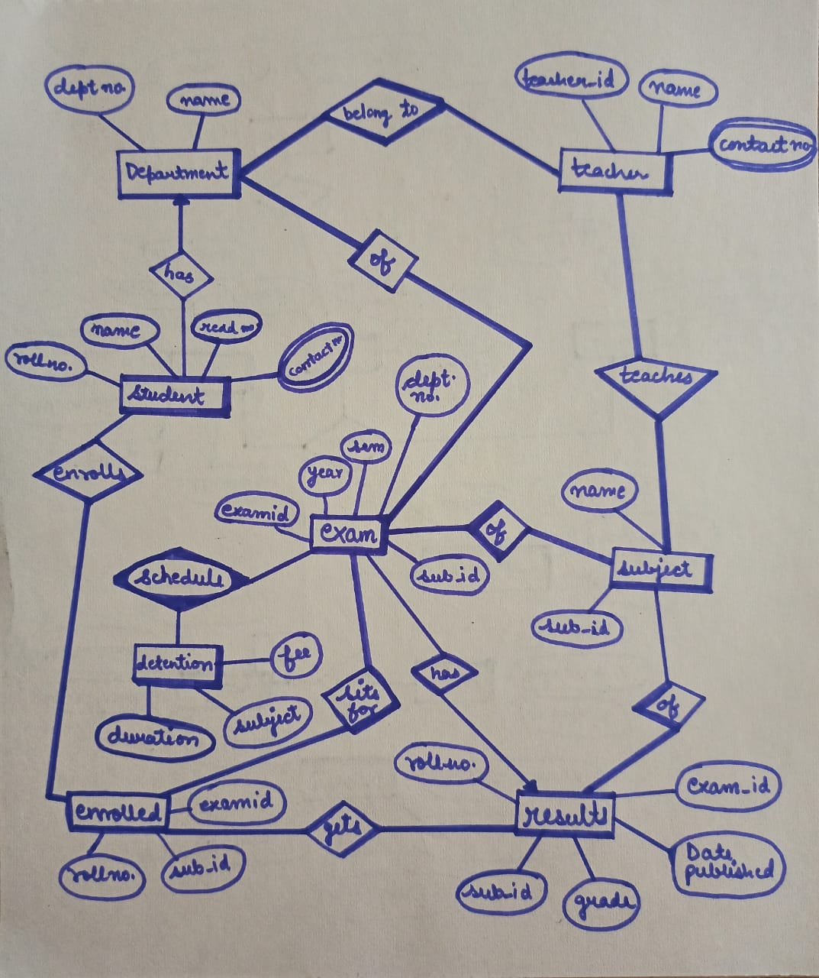

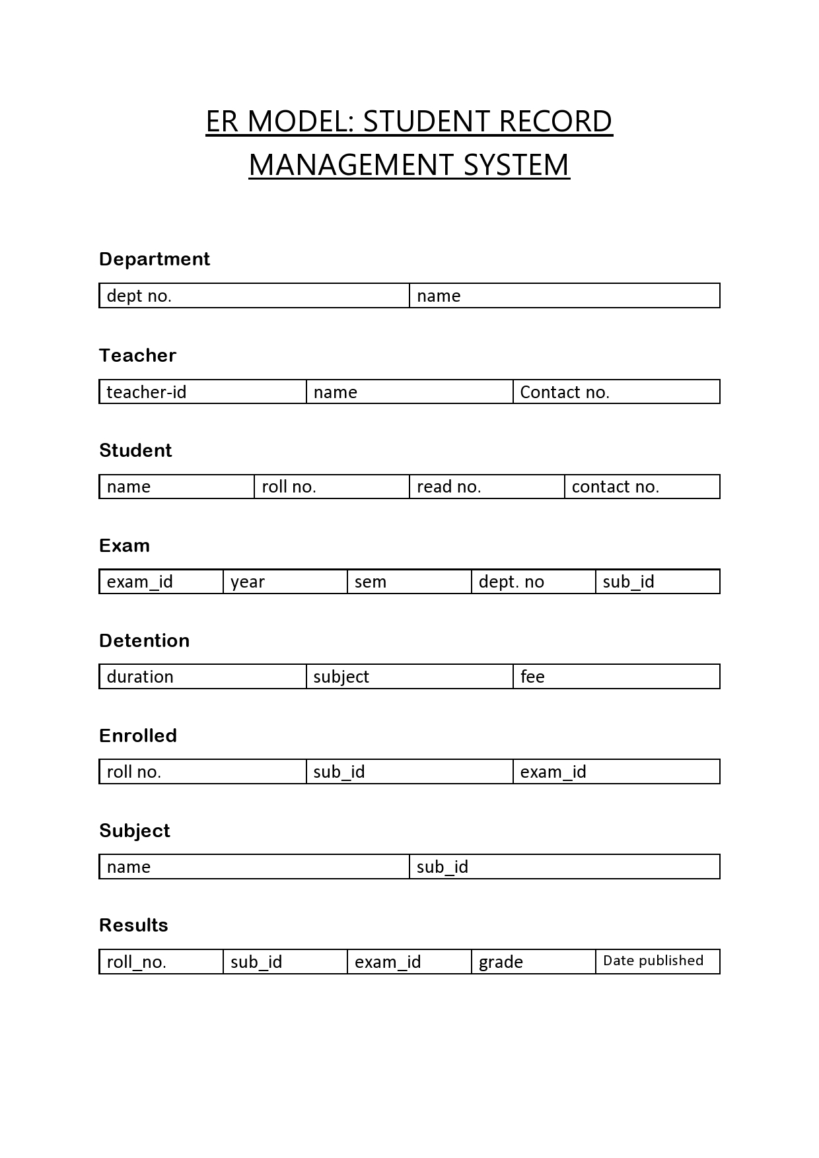

1.CREATION OF DATABASE:

create database SRMS_BHRIGU_HARSH_ADITI;

Query OK, 1 row affected (0.014 sec)

MariaDB [(none)]> USE SRMS_BHRIGU_HARSH_ADITI;

Database changed

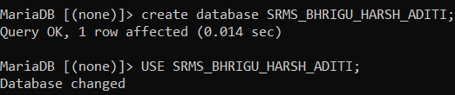

1.1 CREATION OF TABLES:

CREATE TABLE DEPARTMENT(NAME VARCHAR(255) NOT NULL,DEPT_NO INT(10) NOT NULL);

CREATE TABLE TEACHER(TEACHER_ID INT(10) NOT NULL,NAME VARCHAR(255),CONTACT_NO INT(12) NOT NULL);

Query OK, 0 rows affected (0.033 sec)

MariaDB [SRMS_BHRIGU_HARSH_ADITI]> CREATE TABLE SUBJECT(NAME VARCHAR(20),SUB_ID INT(10) NOT NULL);

CREATE TABLE RESULTS(SUB_ID INT(10) NOT NULL,GRADE VARCHAR(2),DATE_PUBLISHED DATE,EXAM_ID INT(10),ROLL_NO INT(10) NOT NULL);

Query OK, 0 rows affected (0.026 sec)

MariaDB [SRMS_BHRIGU_HARSH_ADITI]> CREATE TABLE ENROLLED(ROLL_NO INT(10) NOT NULL,SUB_ID INT(10),EXAM_ID INT(10) NOT NULL);

Query OK, 0 rows affected (0.034 sec)

MariaDB [SRMS_BHRIGU_HARSH_ADITI]> CREATE TABLE EXAM(EXAM_ID INT(10) NOT NULL,YEAR YEAR,SEM INT(10),DEPT_NO INT(10),SUB_ID INT(10));





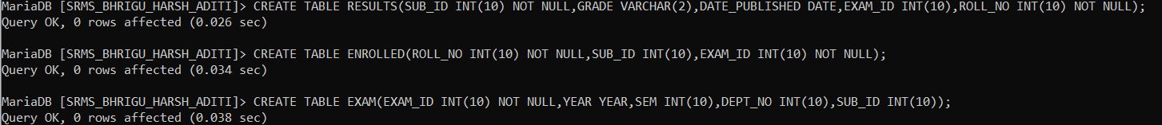



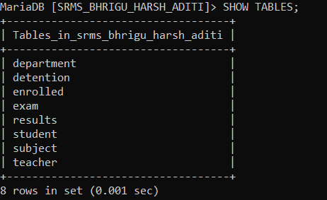

2.ALTERATION OF TABLES:

MariaDB [srms_BHRIGU_HARSH_ADITI]> ALTER TABLE DEPARTMENT

-> ADD CONSTRAINT PRIMARY KEY PK1 (NAME);

Query OK, 0 rows affected, 1 warning (0.084 sec)

Records: 0 Duplicates: 0 Warnings: 1

MariaDB [srms_BHRIGU_HARSH_ADITI]> DESC DETENTION;

+----------+--------------+------+-----+---------+-------+

| Field | Type | Null | Key | Default | Extra |

+----------+--------------+------+-----+---------+-------+

| DURATION | date | YES | | NULL | |

| NAME | varchar(255) | YES | | NULL | |

| SUBJECT | varchar(20) | YES | | NULL | |

| FEES | int(6) | YES | | NULL | |

+----------+--------------+------+-----+---------+-------+

4 rows in set (0.022 sec)

MariaDB [srms_BHRIGU_HARSH_ADITI]> ALTER TABLE DETENTION

-> ADD CONSTRAINT PRIMARY KEY PK1 (NAME);

Query OK, 0 rows affected, 1 warning (0.094 sec)

Records: 0 Duplicates: 0 Warnings: 1

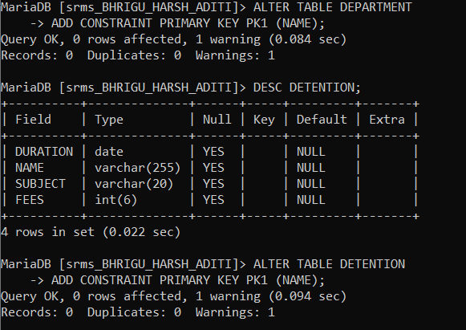



3.INSERTION OF DATA:

DESC DEPARTMENT;

+---------+--------------+------+-----+---------+-------+

| Field | Type | Null | Key | Default | Extra |

+---------+--------------+------+-----+---------+-------+

| NAME | varchar(255) | NO | | NULL | |

| DEPT_NO | int(10) | NO | | NULL | |

+---------+--------------+------+-----+---------+-------+

2 rows in set (0.039 sec)

MariaDB [SRMS_BHRIGU_HARSH_ADITI]> INSERT INTO DEPARTMENT(NAME,DEPT_NO)

-> VALUES

-> ('BHRIGU',1234),

-> ('ADITI',1233),

-> ('HARSH',1233);

Query OK, 3 rows affected (0.003 sec)

Records: 3 Duplicates: 0 Warnings: 0

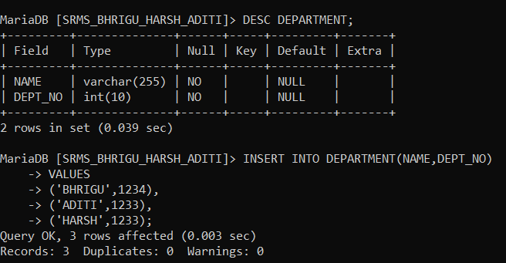

INSERT INTO DEPARTMENT(NAME,DEPT_NO);

ERROR 1064 (42000): You have an error in your SQL syntax; check the manual that corresponds to your MariaDB server version for the right syntax to use near '' at line 1

MariaDB [SRMS_BHRIGU_HARSH_ADITI]> INSERT INTO DEPARTMENT(NAME,DEPT_NO)

-> VALUES

-> ('ACADEMICS',1),

-> ('SPORTS',2),

-> ('CARRER_DEV',3),

-> ('FEES',4),

-> ('INFRA',5);

Query OK, 5 rows affected (0.010 sec)

Records: 5 Duplicates: 0 Warnings: 0

MariaDB [SRMS_BHRIGU_HARSH_ADITI]> DESC ENROLLED;

+---------+---------+------+-----+---------+-------+

| Field | Type | Null | Key | Default | Extra |

+---------+---------+------+-----+---------+-------+

| ROLL_NO | int(10) | NO | | NULL | |

| SUB_ID | int(10) | YES | | NULL | |

| EXAM_ID | int(10) | NO | | NULL | |

+---------+---------+------+-----+---------+-------+

3 rows in set (0.035 sec)

MariaDB [SRMS_BHRIGU_HARSH_ADITI]> INSERT INTO ENROLLED(ROLL_NO,SUB_ID,EXAM_ID)

-> VALUES

-> (1074,003,1276),

-> (1065,002,5634),

-> (1082,001,5644);

Query OK, 3 rows affected (0.010 sec)

Records: 3 Duplicates: 0 Warnings: 0

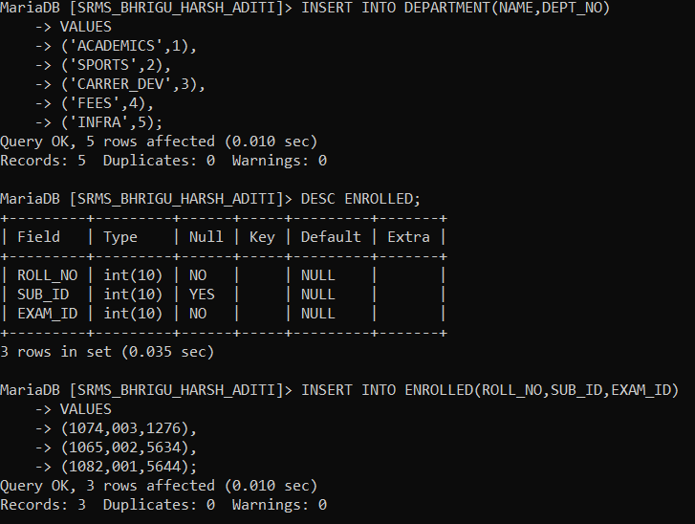

MariaDB [SRMS_BHRIGU_HARSH_ADITI]> DESC EXAM;

+---------+---------+------+-----+---------+-------+

| Field | Type | Null | Key | Default | Extra |

+---------+---------+------+-----+---------+-------+

| EXAM_ID | int(10) | NO | | NULL | |

| YEAR | year(4) | YES | | NULL | |

| SEM | int(10) | YES | | NULL | |

| DEPT_NO | int(10) | YES | | NULL | |

| SUB_ID | int(10) | YES | | NULL | |

+---------+---------+------+-----+---------+-------+

5 rows in set (0.036 sec)

MariaDB [SRMS_BHRIGU_HARSH_ADITI]> INSERT INTO EXAM(EXAM_ID,YEAR,SEM,DEPT_NO,SUB_ID)

-> VALUES

-> (1276,'2023',3,1,003),

-> (5634,'2022',2,2,002),

-> (5644,'2022',1,3,001);

Query OK, 3 rows affected (0.002 sec)

Records: 3 Duplicates: 0 Warnings: 0

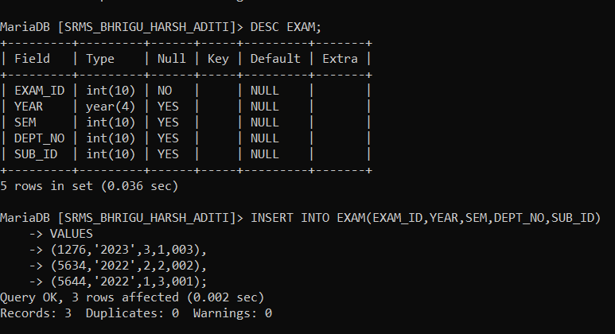

MariaDB [SRMS_BHRIGU_HARSH_ADITI]> DESC DETENTION;

+----------+--------------+------+-----+---------+-------+

| Field | Type | Null | Key | Default | Extra |

+----------+--------------+------+-----+---------+-------+

| DURATION | date | YES | | NULL | |

| NAME | varchar(255) | YES | | NULL | |

| SUBJECT | varchar(20) | YES | | NULL | |

| FEES | int(6) | YES | | NULL | |

+----------+--------------+------+-----+---------+-------+

4 rows in set (0.032 sec)

MariaDB [SRMS_BHRIGU_HARSH_ADITI]> INSERT INTO DETENTION(DURATION,NAME,SUBJECT,FEES)

-> VALUES

-> ('2020-2-3','BHRIGU','DBMS',4000),

-> ('2020-6-9','ADITI','JAVA',4000),

-> ('2020-1-16','HARSH',NULL,4000);

Query OK, 3 rows affected (0.011 sec)

Records: 3 Duplicates: 0 Warnings: 0

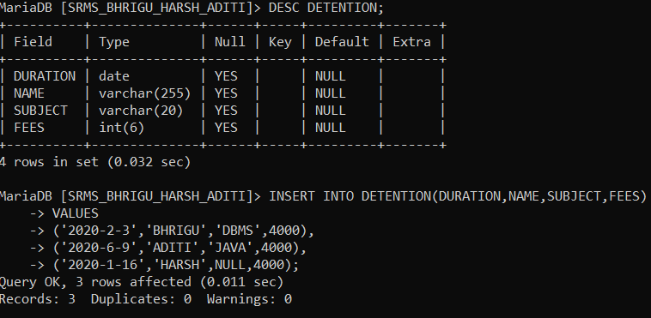

MariaDB [SRMS_BHRIGU_HARSH_ADITI]> INSERT INTO RESULTS(SUB_ID,GRADE,DATE_PUBLISHED,EXAM_ID,ROLL_NO)

-> VALUES

-> (1122,'A+','2020-3-12',233,1074),

-> (1154,'A','2019-5-12',232,1065),

-> (1124,'O','2020-7-11',132,1082);

Query OK, 3 rows affected (0.011 sec)

Records: 3 Duplicates: 0 Warnings: 0

MariaDB [SRMS_BHRIGU_HARSH_ADITI]> SELECT * FROM STUDENT;

Empty set (0.003 sec)

MariaDB [SRMS_BHRIGU_HARSH_ADITI]> DESC STUDENT;

+------------+--------------+------+-----+---------+-------+

| Field | Type | Null | Key | Default | Extra |

+------------+--------------+------+-----+---------+-------+

| ROLL_NO | int(12) | YES | | NULL | |

| NAME | varchar(255) | YES | | NULL | |

| REG_NO | int(10) | YES | | NULL | |

| CONTACT_NO | int(12) | YES | | NULL | |

+------------+--------------+------+-----+---------+-------+

4 rows in set (0.064 sec)

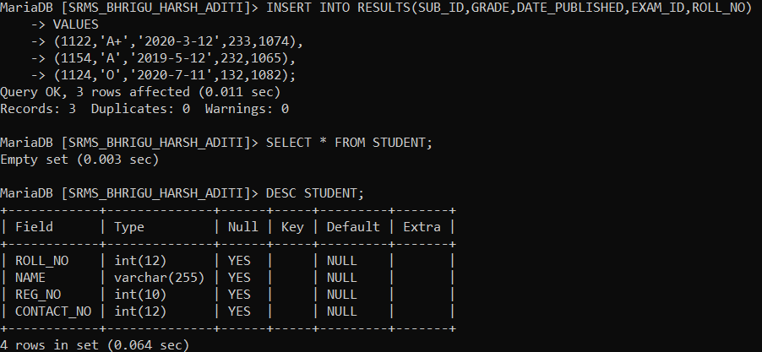

MariaDB [SRMS_BHRIGU_HARSH_ADITI]> INSERT INTO STUDENT(ROLL_NO,NAME,REG_NO,CONTACT_NO)

-> VALUES

-> (1074,'BHRIGU',232,123145645),

-> (1065,'ADITI',823,543324545),

-> (1082,'HARSH',823,545424567);

Query OK, 3 rows affected (0.011 sec)

Records: 3 Duplicates: 0 Warnings: 0

MariaDB [SRMS_BHRIGU_HARSH_ADITI]> SELECT * FROM SUBJECT;

Empty set (0.009 sec)

MariaDB [SRMS_BHRIGU_HARSH_ADITI]> DESC SUBJECT;

+--------+-------------+------+-----+---------+-------+

| Field | Type | Null | Key | Default | Extra |

+--------+-------------+------+-----+---------+-------+

| NAME | varchar(20) | YES | | NULL | |

| SUB_ID | int(10) | NO | | NULL | |

+--------+-------------+------+-----+---------+-------+

2 rows in set (0.031 sec)

MariaDB [SRMS_BHRIGU_HARSH_ADITI]> INSERT INTO SUBJECT(NAME,SUB_ID)

-> VALUES

-> ('DBMS',1232),

-> ('OOPS',1233),

-> ('CAO',1234),

-> ('FRENCH',1235),

-> ('PYTHON',1246);

Query OK, 5 rows affected (0.003 sec)

Records: 5 Duplicates: 0 Warnings: 0

MariaDB [SRMS_BHRIGU_HARSH_ADITI]> DESC TEACHER;

+------------+--------------+------+-----+---------+-------+

| Field | Type | Null | Key | Default | Extra |

+------------+--------------+------+-----+---------+-------+

| TEACHER_ID | int(10) | NO | | NULL | |

| NAME | varchar(255) | YES | | NULL | |

| CONTACT_NO | int(12) | NO | | NULL | |

+------------+--------------+------+-----+---------+-------+

3 rows in set (0.033 sec)

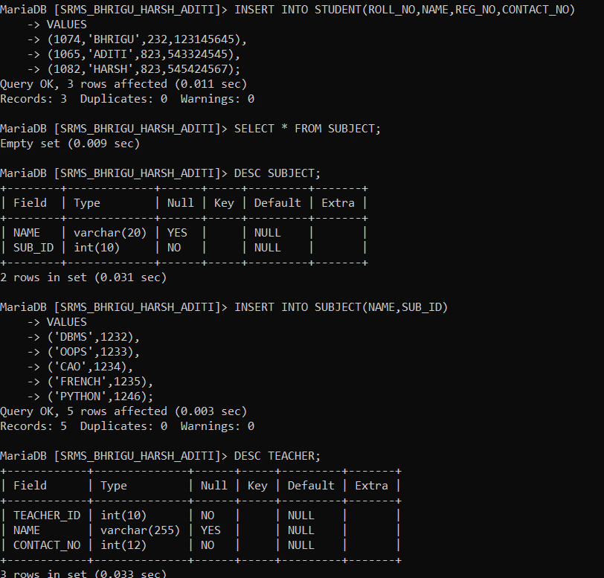

MariaDB [SRMS_BHRIGU_HARSH_ADITI]> INSERT INTO TEACHER(TEACHER_ID,NAME,CONTACT_NO)

-> VALUES

-> (1,'SHREYA.M',566789776),

-> (2,'JYOTI.P',566453424),

-> (3,'SNIGDHA',566456434),

-> (4,'HANU.B',566434232);

Query OK, 4 rows affected (0.002 sec)

Records: 4 Duplicates: 0 Warnings: 0

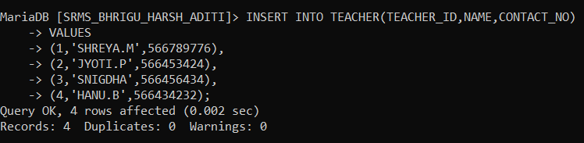

4.SELECTION OF DATA



MariaDB [SRMS_BHRIGU_HARSH_ADITI]> SELECT * FROM DEPARTMENT;

+------------+---------+

| NAME | DEPT_NO |

+------------+---------+

| ACADEMICS | 1 |

| SPORTS | 2 |

| CARRER_DEV | 3 |

| FEES | 4 |

| INFRA | 5 |

+------------+---------+

5 rows in set (0.000 sec)

MariaDB [SRMS_BHRIGU_HARSH_ADITI]> SELECT * FROM DETENTION;

+------------+--------+---------+------+

| DURATION | NAME | SUBJECT | FEES |

+------------+--------+---------+------+

| 2020-02-03 | BHRIGU | DBMS | 4000 |

| 2020-06-09 | ADITI | JAVA | 4000 |

| 2020-01-16 | HARSH | NULL | 4000 |

+------------+--------+---------+------+

3 rows in set (0.000 sec)

MariaDB [SRMS_BHRIGU_HARSH_ADITI]> SELECT * FROM ENROLLED;

+---------+--------+---------+

| ROLL_NO | SUB_ID | EXAM_ID |

+---------+--------+---------+

| 1074 | 3 | 1276 |

| 1065 | 2 | 5634 |

| 1082 | 1 | 5644 |

+---------+--------+---------+

3 rows in set (0.000 sec)

MariaDB [SRMS_BHRIGU_HARSH_ADITI]> SELECT * FROM SUBJECT;

+--------+--------+

| NAME | SUB_ID |

+--------+--------+

| DBMS | 1232 |

| OOPS | 1233 |

| CAO | 1234 |

| FRENCH | 1235 |

| PYTHON | 1246 |

+--------+--------+

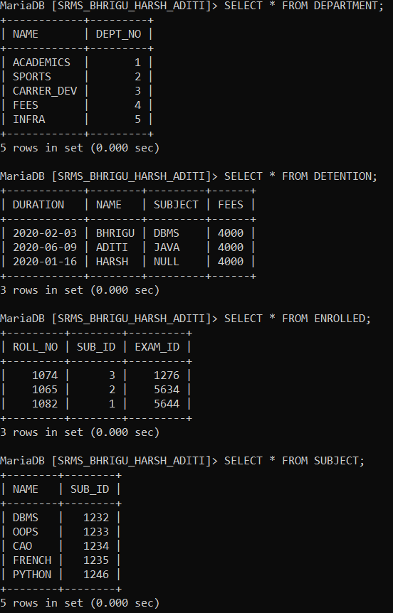

MariaDB [SRMS_BHRIGU_HARSH_ADITI]> SELECT * FROM TEACHER;

+------------+----------+------------+

| TEACHER_ID | NAME | CONTACT_NO |

+------------+----------+------------+

| 1 | SHREYA.M | 566789776 |

| 2 | JYOTI.P | 566453424 |

| 3 | SNIGDHA | 566456434 |

| 4 | HANU.B | 566434232 |

+------------+----------+------------+

4 rows in set (0.000 sec)

MariaDB [SRMS_BHRIGU_HARSH_ADITI]> SELECT * FROM STUDENT;

+---------+--------+--------+------------+

| ROLL_NO | NAME | REG_NO | CONTACT_NO |

+---------+--------+--------+------------+

| 1074 | BHRIGU | 232 | 123145645 |

| 1065 | ADITI | 823 | 543324545 |

| 1082 | HARSH | 823 | 545424567 |

+---------+--------+--------+------------+

3 rows in set (0.000 sec)

MariaDB [SRMS_BHRIGU_HARSH_ADITI]> SELECT * FROM RESULTS;

+--------+-------+----------------+---------+---------+

| SUB_ID | GRADE | DATE_PUBLISHED | EXAM_ID | ROLL_NO |

+--------+-------+----------------+---------+---------+

| 1122 | A+ | 2020-03-12 | 233 | 1074 |

| 1154 | A | 2019-05-12 | 232 | 1065 |

| 1124 | O | 2020-07-11 | 132 | 1082 |

+--------+-------+----------------+---------+---------+

MariaDB [SRMS_BHRIGU_HARSH_ADITI]> SELECT * FROM EXAM;

+---------+------+------+---------+--------+

| EXAM_ID | YEAR | SEM | DEPT_NO | SUB_ID |

+---------+------+------+---------+--------+

| 1276 | 2023 | 3 | 1 | 3 |

| 5634 | 2022 | 2 | 2 | 2 |

| 5644 | 2022 | 1 | 3 | 1 |

+---------+------+------+---------+--------+

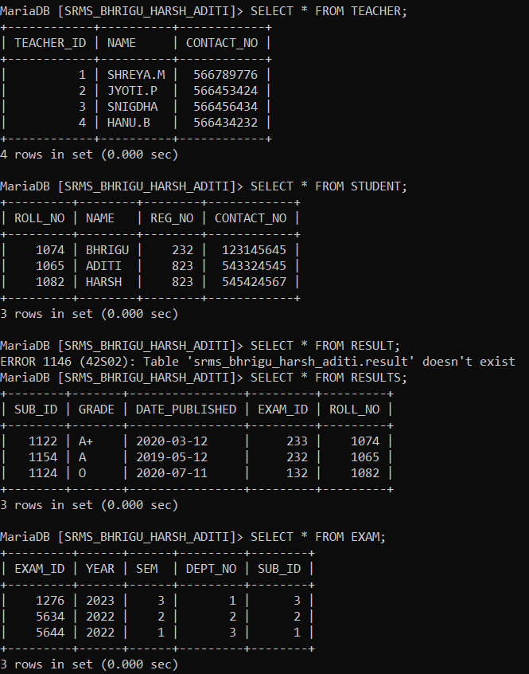

5.UPDATION OF DATABASE

UPDATE TEACHER

-> SET CONTACT_NO=231123312

-> WHERE TEACHER_ID=1;

Query OK, 1 row affected (0.002 sec)

Rows matched: 1 Changed: 1 Warnings: 0

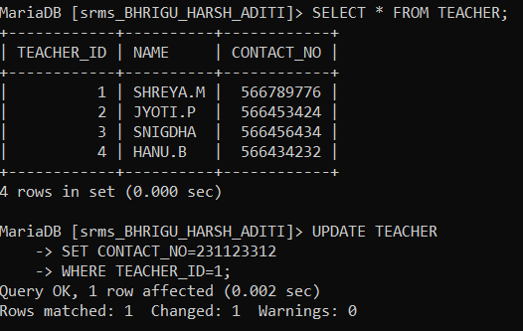

UPDATE EXAM

-> SET SEM=3

-> WHERE YEAR=2022;

Query OK, 2 rows affected (0.010 sec)

Rows matched: 2 Changed: 2 Warnings: 0

MariaDB [srms_BHRIGU_HARSH_ADITI]> SELECT * FROM EXAM;

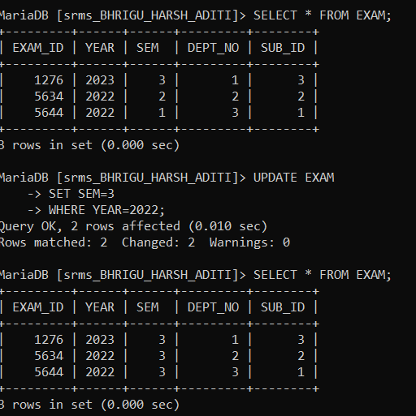

DELETION OF DATABASE

SELECT * FROM DEPARTMENT;

+------------+---------+

| NAME | DEPT_NO |

+------------+---------+

| ACADEMICS | 1 |

| CARRER_DEV | 3 |

| FEES | 4 |

| INFRA | 5 |

| SPORTS | 2 |

+------------+---------+

5 rows in set (0.000 sec)

MariaDB [srms_BHRIGU_HARSH_ADITI]> DELETE FROM DEPARTMENT WHERE DEPT_NO =3;

Query OK, 1 row affected (0.010 sec)

MariaDB [srms_BHRIGU_HARSH_ADITI]> SELECT * FROM DEPARTMENT;

+-----------+---------+

| NAME | DEPT_NO |

+-----------+---------+

| ACADEMICS | 1 |

| FEES | 4 |

| INFRA | 5 |

| SPORTS | 2 |

+-----------+---------+

4 rows in set (0.000 sec)

